St. Matthew’s Primary School
Remote Learning Policy

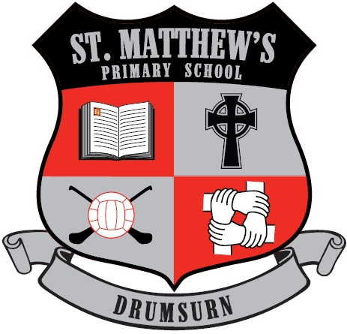

March 2020 in Response to the Coronavirus Outbreak.

UNCRC Article 28: Children have the right to the best possible education.

Signed Principal:______________________________
Signed Chair of the BOG:______________________
Date Ratified:_____________________________
In the event of long term closure, staff at St. Matthew’s Primary School will continue to provide education and support to our pupils using remote learning. In this case, all learning will be conducted using the school website/school app & text. This will allow staff to keep in regular contact, in a professional and confidential manner with each pupil in their class. Teachers will be able to schedule learning in a manner that does not overwhelm or concern our pupils. Teaching and learning can be tailored, changed and updated as time progresses, allowing for replication of classroom activity to the best of our ability. In all communications we will adhere to our commitment to maintaining pupil wellbeing.
We realise that the circumstances that cause our school to close will affect families in a number of ways. In our planning and expectations, we are aware of the need for flexibility from all sides: parents may be trying to work from home and so access to technology as a family may be limited; teachers may be trying to manage their home situation and the learning of their own children; systems may not always function as they should. An understanding of, and willingness to adapt to, these difficulties on all sides is essential for success and for us to continue the positive working relationships between home, school and our community.
In the case of long term closure, we believe that it is in the best interests of our pupils that we continue to provide structured support to the best of our ability. Bearing in mind the need for flexibility, we understand that work maybe completed out of sync with when it is shared and as such, no deadlines will be set. That said, the work that pupils engage in during a period of closure will be part of our current planning and so cannot be considered as optional. Pupils and parents should consider the arrangements as set out in this document as highly recommended.
The first day of any extended closure will be used by teachers to prepare for the coming period and there will be no remote learning scheduled. The programme of remote learning will start from Monday 30th March 2020.

Teaching and Classroom Assistants will work together to:
- Share teaching and activities with their class on a 2-3 week basis, in preparation for the next 2-3 weeks, through the school website/school app/see-saw/class pages & school text.
- Continue teaching in line with current, extensive planning that is already in place throughout the school.
- Give credence to the fact that learning remotely will be more difficult, so tasks will be shortened and supported in smaller steps to allow for this.
- Keep in contact with parents/pupils through the school website/school app & the school text only.
- Check work related emails at least twice a day at 9am & 1pm.
- During normal teaching hours adequately plan, prepare, research resources for home learning.
- Take regular breaks away from the computer or iPad to engage in other professional duties as much as circumstances allow.
- If unwell themselves, be covered by another staff member for sharing of activities each day.
- Adhere to the school’s E-Safety Policy, social media policy & all relevant safeguarding policies.
- Classroom Assistants or Teachers may sometimes contact families by phone call at some stage during long periods of school closure, this will be a professional ‘Check-in’ phone call to see how pupils are doing.

- Pupils will:

- Be assured that wellbeing is at the forefront of our thoughts and they should take regular breaks, get fresh air, exercise and maintain a reasonable balance between online engagement and offline activities.
- Potentially work a day behind what has been shared through the school website/school app/ see-saw/ class pages & text, if it is only possible to access technology in the evenings. Learning can be accessed and completed.
- Only access the material shared by the school and will ask for parental permission to use technology for anything beyond that.
- Read daily, either independently or with an adult.
- Consider using the school closure time to learn a new skill, follow their own interests to discover more about the world around us or be creative.
- Adhere to the school’s E-Safety Policy, social media policy & all relevant safeguarding policies.

Parents will:
- Support their child’s learning to the best of their ability.
- Encourage their child to access and engage with the school website posts from their teacher.
- Not screenshot or copy any information, messages or posts to share on social media or any other platform outside of school website/school app & text.
- Adhere to our school Social Media Policy
- Know they can continue to contact their class teacher as normal through the staff professional email only if they require support of any kind.
- Staff emails are: akealey695@c2kni.net, cknox598@c2kni.net, kmcgurk795@c2kni.net, kvail206@c2kni.net
- Check their child’s completed work each day and encourage the progress that is being made.
- Be mindful of mental well-being of both themselves and their child and encourage their child to take regular breaks, play games, get fresh air and relax.
- Respond to any ‘Check-in’ phone call from your child’s class teacher or Classroom Assistant in a supportive and constructive manner.

Signed: Mrs AM Kealey
March 2020
Review Date: March 2024

