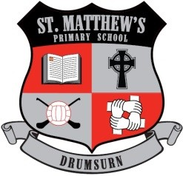
St Matthew’s Primary School
296 Drumsurn Road
Limavady
BT49 0PX
Telephone 028777 63887
Principal : Mrs AM Kealey BA Hons (ED) PQH NI
Email: akealey695@stmatthewsps.drumsurn.ni.sch.uk

Dear Parent/Guardian,
Only 4 more sleeps until the big day arrives. It is hard to believe that Christmas is upon us and that another year has gone by so quickly! We have been so busy in school preparing to celebrate Christmas during this season of advent.
As always, the support from our parents remains a constant and it was wonderful to be able to welcome so many of you into our school to enjoy our Christmas performances. The feedback has just been amazing! I’m sure you were just so proud of your children as we were too!
Our staff and pupils have worked so hard as ever this term and there has been a greater buzz around school in preparation for the ‘Big Day’.
Our prayer is that each of you will enjoy a happy, healthy and peaceful Christmas with your family and friends.
We look forward to 2023 and to a bright New Year, a year in which all our pupils will continue to grow and flourish in St Matthews’s P.S.
Our school will reopen for pupils on Wednesday 4th January 2023.
Have a lovely Christmas with all your families and I hope Santa Claus is good to each and everyone of you!
Best wishes
Mrs. AM Kealey
Principal

