St Matthew’s Primary School
296 Drumsurn Road
Limavady
BT49 0PX
Telephone 028777 63887
Email: akealey695@stmatthewsps.drumsurn.ni.sch.uk
Principal : Mrs AM Kealey BA Hons (ED) PQH NI
04/09/2023
Dear Parents

A huge welcome back to everyone in our entire school community. I trust you all had a happy and healthy Summer break. The children have returned to school looking fantastic in their new uniforms and all ready for another exciting and very busy year ahead! I had the opportunity to speak with many of the children last week about their summer break. It was lovely to hear the many wonderful stories of children spending quality time with their friends and family, over the summer holidays. The start of the school term is always an exciting one and, at times, it can also be a really busy time for school staff and families alike and you may start to get a lot of information from school in relation to the year ahead. Please take time to read any communication that comes from school - as always, if you have any questions / queries please do not hesitate to make contact with your child's class teacher.

As a new school year begins, we ask all of our pupils to take responsibility for their own development by:
working hard, coming to school prepared and on time, being courteous and polite, respectful and kind. A new school year is a great time to reassess your goals and aim high!!

I would like to extend a very warm welcome to our new Primary One pupils and parents who will be starting over the next three weeks. For our new parents this may be the first time you have been back in a school setting since you were there. A lot of things have changed. I do hope that you and your child will have positive experiences whilst here at St. Matthew’s. Should you have any worries/concerns please make an appointment to talk to your child’s class teacher or alternatively contact me here at the school.

Please ensure children are in school, ready for the start of the school day at 8:55am. Children can be dropped off after 8:45am when they will be supervised in the School Assembly Hall, unless attending the Breakfast Club.

Children are not to be dropped off prior to 8:45am as supervision IS NOT available, unless attending the Breakfast Club.

Reminders:
St. Matthew’s is a nut-free zone. Please do not send anything with nuts in it, eg Nutella, peanut butter, to school.

Can we please remind you that school starts at 8.55am.

Children should go directly to the assembly hall for morning assembly. P1 buddies will meet the New P1 children at the school porch and take them to the assembly hall. School doors will close at 9:10am. We would therefore encourage children to be in on good time for the start of the school day. Thanks for your help with this matter.
The main entrance is to be used by all parents/guardians and visitors and for security purposes works on a buzzer system. All parents/guardians and visitors must report to reception upon arrival. If a child is being picked up early for any reason, the Secretary or Class teacher will bring the pupil to school porch.

Uniform
The children have returned to school looking so smart in their new uniforms and all ready for the new school year ahead. Our school uniform is an important expression of our pride in ourselves as a school and we expect all students to be in correct uniform at all times. Please remember leggings are not to be worn as part of our school uniform.
The school photographer will visit school on Thursday 28th September to take individual child photographs and sibling groups.
Thank you
As always the school looks in great condition. Many thanks to Paula Rodgers, Rachel Rodgers and Sean Hamill for all their hard work during the summer holidays.

Pupil Attendance 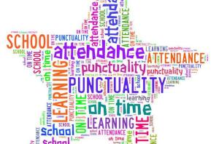

Pupil Attendance increased by 2.22 % last year but this is still down on previous years. We would love to see this improve this year! All absences, appointments etc. must be explained by letter to the class teacher. These are kept on file. Thank you for your support in this area.

Attendance Matters!
As you are already aware it is essential that your child attends school regularly and maintain a pattern of good attendance throughout their school career. Excellent attendance at school is important to allow children to fulfil their potential. Every single day a child is absent from school equates to a day of lost learning. In school we have an obligation to monitor children’s attendance very closely and to report attendance percentages to the Education Welfare Officer on a regular basis. Punctuality is essential as each time a child is late to school they are marked late and when they arrive after registration has closed (09:15)- this impacts on their attendance.
If your child’s attendance is causing concern, we will follow the agreed procedures in school:
• The class teacher will inform you of your child’s attendance percentage (below 90%)
• If attendance continues to cause concern, then you will receive a letter from DTCP in school
• If attendance continues to cause concern, then you will be invited to a pre-referral meeting in school. Our EWO may be in attendance, Marina Doherty
• If your child’s attendance is 85% or below/causing concern, we are obliged to make a referral to EWS.
It should be noted that holidays must not be arranged during the school terms. Sufficient notice of school holiday dates is given to parents/guardians in order for holidays to be arranged during these times. We as a school, want to help support you in improving your child’s attendance in order for them to reach their full potential. If you need to discuss any issues surrounding absences or support strategies that can be put in place to improve attendance, during the school year, please contact Mrs Kealey at the school.

Road Safety  As a school community we have been deeply shocked and saddened by the sudden and untimely death of our esteemed colleague Mrs Gabrielle Feeney. She was hugely popular with all the pupils, staff and wider school community and was well -known for her cheery personality. We will miss her terribly and were truly blessed to have Gabrielle there each day to cross the children safely across the road.  As Education Authority have decided not to replace this key role in our school it is imperative that we have our parents on board to walk our children to and from the school entrance safely each day. Thank you for you support with this matter. | 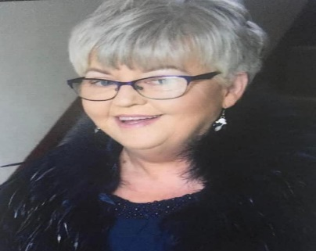

Contact details. We would ask that you ensure we have your up to date details, particularly mobile phone numbers. Please send any change of information to Mrs Mullan in the office. We need your mobile number for you to be able to receive text messages. If you are not receiving texts, please let us know.
School Website/APP
Our school website will give information on lots of aspects of our school life. We regularly upload school letters/newsletters/ photographs giving you a flavour of our very busy school here at St. Matthew’s P.S. Please download the school app SCHOOLS NI APP to receive all notifications from us. Any problems please contact us at school.

Free school meals
I would like to remind all parents of the importance of registering your child for free school meals. The Department of Education statistics continue to show that quite a large percentage of children who may be entitled to a free school meal are not doing so. It is important to note that even if your child is registered to receive a meal that they can still opt to bring their own lunch on any particular day. Further information on entitlements or to register can be done online at https://www.eani.org.uk/financial-help/free-school-meals-uniform-grants
PLEASE REGISTER IF YOU THINK YOUR CHILD IS ENTITLED TO FREE SCHOOL MEALS
School Dinners cost £2.60 per day or £13 per week and should be paid on a Monday morning. The new school dinner menu was posted on our school website and sent out via the school app. Your child can then choose what day/days they want to take dinners. Our dinners are excellent and both healthy and nourishing.
Please send in the correct dinner money (clearly labelled with child’s name and days they would like to have dinner) with your child to speed up the collection of monies. This is very important as it allows us to free up our school secretary to complete other administrative tasks. School money pouches can be purchased from the school office at a cost of £4 per pack.

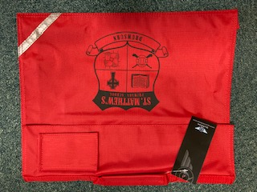 | P1/P3 School Bags  If you would like to purchase one of our new school bags you can purchase one from the school office costing £6.50.

Safeguarding:
If you feel that you need to talk to school about any pastoral care matter in relation to your child or have any concerns re another child, please make contact with Mrs Kealey Designated Teacher for child protection or Mr Proctor Deputy Designated Teacher.
Healthy Breaks/Lunch
Here at St Matthew’s P.S. we promote Healthy Break, Healthy Snacks and Healthy Lunch boxes. All pupils are required to bring a healthy snack e.g. fruit, yoghurt vegetables, cheese at break time and to bring water each day to school.

PTA I want to personally thank all the members of the PTA who work tirelessly to raise much needed funds for our school. I would actively encourage all new parents and those others with an interest in the well-being of the school to become involved. If you feel that you can make a contribution in any way, please speak to either myself or any member of the PTA.

Flu Vaccination Program:
A regional video has been developed by PHA to raise awareness of the importance of the flu vaccine and encourage parents to consent to their children being immunised. The link for the video is: https://vimeo.com/452145182.
Children will be given their vaccination on Wednesday 18th October in school.

Before/ After school Clubs
Breakfast Club has restarted from today 4th September and runs from 8am – 8.40am. The cost is £1 per child per day £5 for the week.
We are hoping to run a selection of after school clubs this year. Further details we be sent home.
Holidays
The Holiday list has been uploaded to the website and a copy has been sent home. Please retain this for your records.
It is also NOT recommended for families to take holidays during Term time.

Staff Changes
We would like to welcome Miss Kealey who will teach our P1/2 class and Mr Proctor who will teach our P6/7 class 3 days a week. We wish Shona McAteer all the best as she begins her maternity leave and we welcome Lynn who will be our new temporary Catering Supervisor in the Canteen.
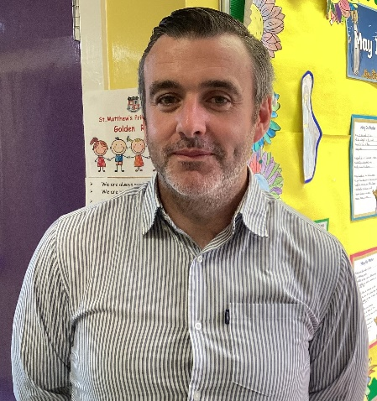 | 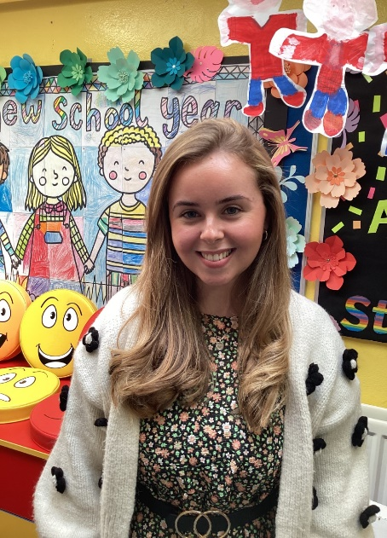

Finally
I look forward to your continued support during our new school term and the year ahead. We all have the same goal which is the very best education for the children in St. Matthew’s P.S. School life is a reflection of family and community life. As always, the incoming year will provide its share of ups and downs but if we all stick together, support and respect each other both as parents and educators then the children can be confident of enjoying another very successful year!
We are a small, happy school and you can rest assured that we will always do our best to cherish and nurture every child. We are all looking forward to the upcoming year and trust that you and your children are also. I wish you all a very happy and successful year with us at St. Matthew’s.

Yours faithfully

AM Kealey

Principal

