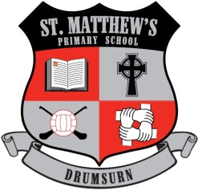 | St Matthew’s Primary School  296 Drumsurn Road  Limavady  BT49 0PX  Telephone 028777 63887  Email: akealey695@stmatthewsps.drumsurn.ni.sch.uk  Principal : Mrs AM Kealey BA Hons (ED) PQH NI

Dear Parent/Guardian,
On 14th January you received a letter from the Limavady Area Principals Group outlining the impact of financial cuts on schools and appealing for support in challenging political representatives to put aside their differences and unite in support of schools.
The Limavady Area Principals Group have now sent letters to politicians and local councillors, inviting them to a meeting on Tuesday 12th February at 2.15pm in St Mary’s Limavady.
The meeting will provide an opportunity for elected representatives to hear the concerns of schools and Principals look forward to hearing what actions are planned by our representatives to address the current financial crisis.
Following this meeting, parents will be informed of the outcome and any further action planned by the Limavady Area Principals Group.

Ballykelly PS, Cumber Claudy PS, Drumachose PS,
Faughanvale PS, Gaelcholáiste Dhoire, Dungiven, Gaelscoil Neachtain, Dungiven,
Gorran PS, Garvagh, Limavady Grammar School,
Limavady High School, Listress PS, St Aidan’s PS, Magilligan, St Canice’s PS, Dungiven,
St Canice’s PS, Feeny, St Colmcille’s PS, Claudy,
St Columba’s PS Ballerin, St John’s PS, Dernaflaw, St Finlough’s PS, Sistrakeel,
St Mary’s PS, Altinure, St Mary’s PS, Gortnaghey, St Mary’s, Limavady,
St Patrick’s College, Dungiven, St Matthew’s PS, Drumsurn,
St Patrick’s and St Joseph’s PS, Garvagh,
St Peter’s and St Paul’s PS, Foreglen, Termoncanice PS, Limavady

