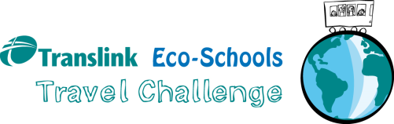

3rd May 2019

Dear Parent/Carer,

This year our school is participating once again in the Translink Eco-Schools Travel Challenge being run in partnership by Keep Northern Ireland Beautiful Eco-Schools and Translink.

Children in all classes will be asked to take part in this challenge over a 2 week period starting on Tuesday 7th May to Friday 17th May.

We will look at what transport pupils currently use to get to and from school and ask you and them to try and make sustainable improvements during this period and beyond. For example: taking the bus, train, walking or cycling – even once a week can make a big difference! You could also consider arranging car sharing with another parent if possible.

This is a fantastic opportunity for our school to work towards becoming more environmentally sustainable by reducing carbon emissions caused by traffic and is a positive step towards reducing car congestion around the school. It is also a healthy and sociable option for our pupils. We will also be using the challenge as a means to achieving our second prestigious Eco-Schools Green Flag award nest year.

Joining the Travel Challenge is free for the school and there will be a special awards ceremony in June to present prizes to the top participants from across Northern Ireland.

There are some great prizes based on sustainable transport to be won for the school and for an individual pupil and their family.

We hope you will support our Translink Eco-Schools Travel Challenge!

For further information on the Translink Eco-Schools Travel Challenge please speak to Mrs O’Connor, our Eco-Schools Co-ordinator, or to me. You can also find more information on the Translink Eco-Schools webpage at -www.translink.co.uk/ecoschools.

Yours Sincerely

Mrs AM Kealey (Principal)

