St Matthew’s Primary School
296 Drumsurn Limavady
BT49 0PX
Telephone 028777 63887
Email: akealey695@stmatthewsps.drumsurn.ni.sch.uk
Principal : Mrs AM Kealey BA Hons (ED) PQH NI

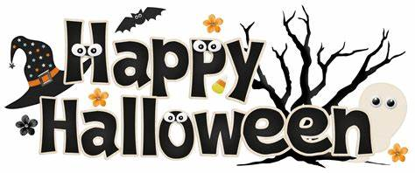

Dear Parents/ Guardians,

Our PTA ’Friends of St. Matthew’s’ are organising a Halloween Disco in school on Friday 25th October from 1:30-3pm. Entry to the disco is £1.

Children should wear their Halloween costumes to school on Friday. Please do not bring any sharp objects or wear scary masks to school which may frighten our younger children. A tuck shop will also be available at the disco.

Please remember our school is a NUT FREE zone.

School will be closed from Monday 28th October -Friday 1st November. It will reopen again on Monday 4th November.

Hope you all have a spooktacular Halloween!

Mrs Kealey

Principal

